Prg181 – group 3
Project 2

Belgium Campus Itversity
Date of Submission –
Group Members: Student ID:
Alexander Kruger (605298)
Ruben Botha (605467)
Reitumetse Mdlapo (605271)
Marvin Netshirando (605733)
Contents
Section 1: Problem Solving Logic: Library Book Management 2
1. Introduction 2
2. Problem Definition 2
3. System Decomposition 3
5. Data Structures Design 4
5.1 Book Representation 4
5.2 Data Storage 4
6. Input-Process-Output (IPO) Model 5
6.1 Inputs 5
6.2 Processes 5
6.3 Outputs 7
Section 2: Pseudocode 8
Main Program 8
Add Book Procedure 9
Search Procedure 10
Borrow Book Procedure 11
Return Book Procedure 12
Display All Books Procedure 13
Section 3: Flowchart 14
Main Program 14
Add Book Procedure 15
Search Procedure 16
Borrow Book Procedure 17
Return Book Procedure 18
Display All Books Procedure 19

Section 1: Problem Solving Logic: Library Book Management

1. Introduction
A library book management system is a program that controls the recording of book information in a library. In addition to maintaining accurate data for the books in the library, this program will have the ability to look up specific books based upon their title or authors’ name. This system also provides the means for a patron to check out and return the books they borrow. A menu driven interface allows users to easily navigate through the different features offered.

2. Problem Definition
The library book management system must be able to meet the following needs:
- store & maintain records of books
- permit users to look up books based upon their title or authors’ name
- allow users to check out & return books
- display all books that are currently available
- prevent multiple patrons from checking out the same book
- Handle any invalid input entered by the user correctly
- continue operating until the patron has completed all tasks

3. System Decomposition
In designing the logic of this system, we broke down its design into small manageable pieces:
- add book
- search book
- check out book
- return book
- show list of books available for checkout
- Exit the program
By using this modular approach, we are improving our systems' modularity, readability and maintainability.
4. Control logic (menu driven design)
We used a simple menu driven control logic where there is a loop allowing users to pick one of several choices while the system is operational; then once the user picks "Exit", the program stops.
Logic flow:
- start the system
- display options to the user
- collects the option selected by the user
- executes the selected operation
- returns to the main menu
- continues looping until the user selects the "Exit" option
This approach helps improve usability and ensures that your program will run consistently.

5. Data Structures Design

5.1 Book Representation
Each book is stored as an object with the following characteristics:
- book id
- title
- authors name
- status (available/unavailable)

5.2 Data Storage
-The system stores and manages each book's data in a predetermined list of books.

6. Input-Process-Output (IPO) Model

6.1 Inputs
- the system utilizes a predefined book collection (list)
- user selection from the menu
- details about a particular book (id, title, author)
- criteria to use when performing a search (Title or Author)
- id number of the book being borrowed or returned

6.2 Processes

Add Book
- Validate the entered input data
- Verify that the id number entered does not already exist for another book
- create a new record representing the added book
- set the status of the new book record to "available"
- store the new record to the collection

Search Book
- accept search parameters entered by the patron
- iterate over the collection of books
- compare the search parameters entered by the patron to those stored in each book's record
- display all matching records

Borrow Book
- prompt user for id number of book they want to check-out
- find the record representing the desired book
- determine if the status property is equal to "available"
- if status = "available", change the status property to "borrowed"; otherwise, display an error message

Return Book
- prompt patron for id number of book being returned
- locate the book with the specified id number
- determine if the status is equal to "borrowed"
- Update status to "available" if valid; otherwise, display an error message

Display Available Books
- traverse through collection of books
- only display those records which have status = "available"

Exit command
- Terminate program

6.3 Outputs
- Confirmation messages to the patron (e.g., success)
- Error messages to the patron (e.g., book not located)
- List of books to the patron (e.g., search results, available books)

Section 2: Pseudocode

Main Program
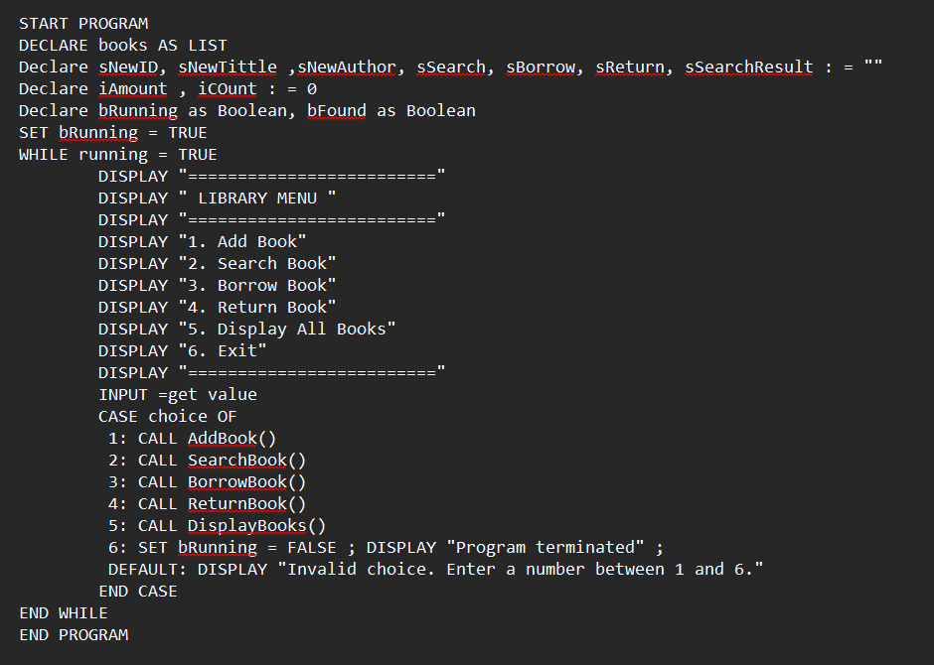

Add Book Procedure
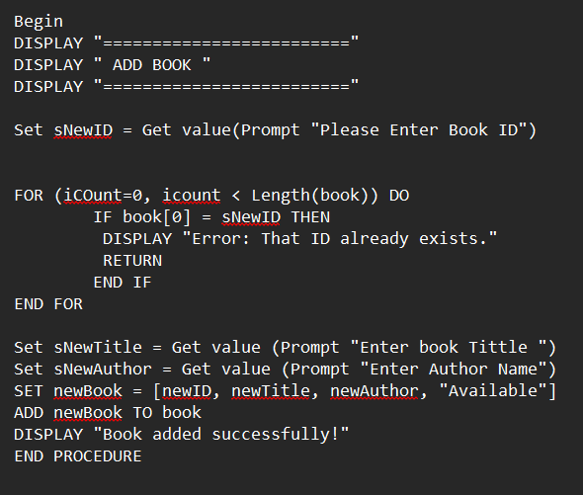

Search Procedure
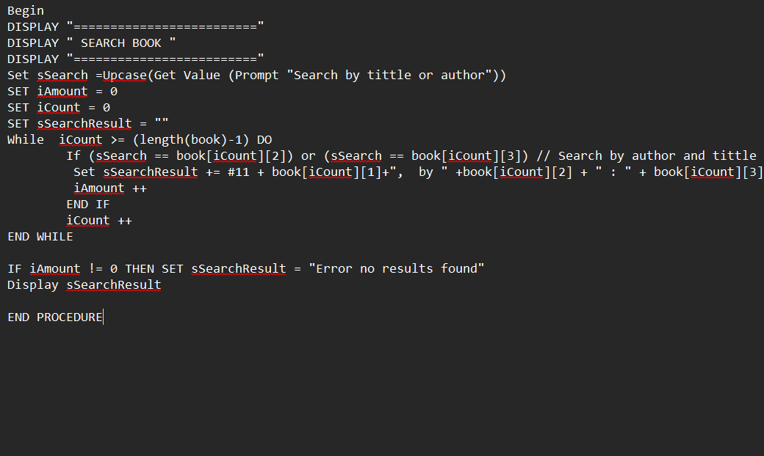

Borrow Book Procedure
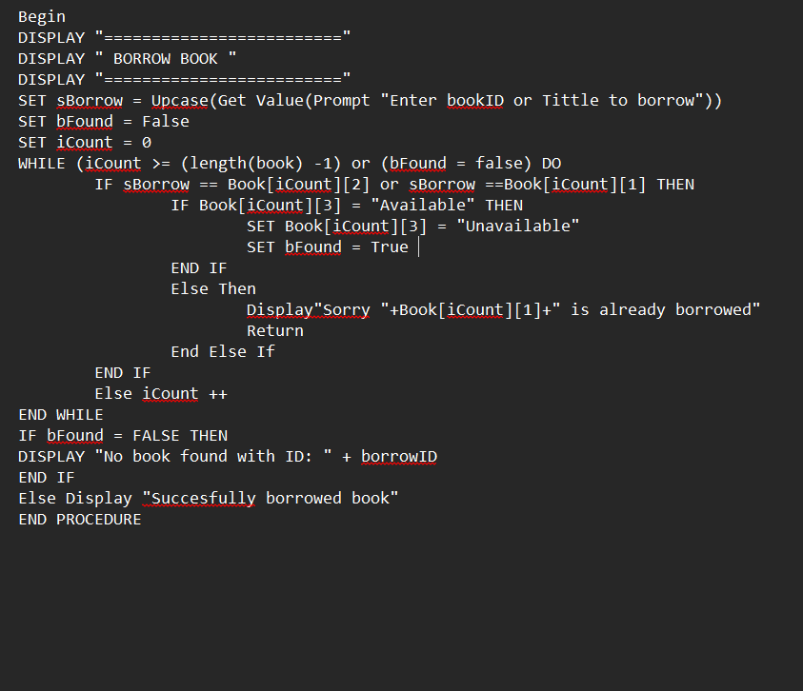

Return Book Procedure
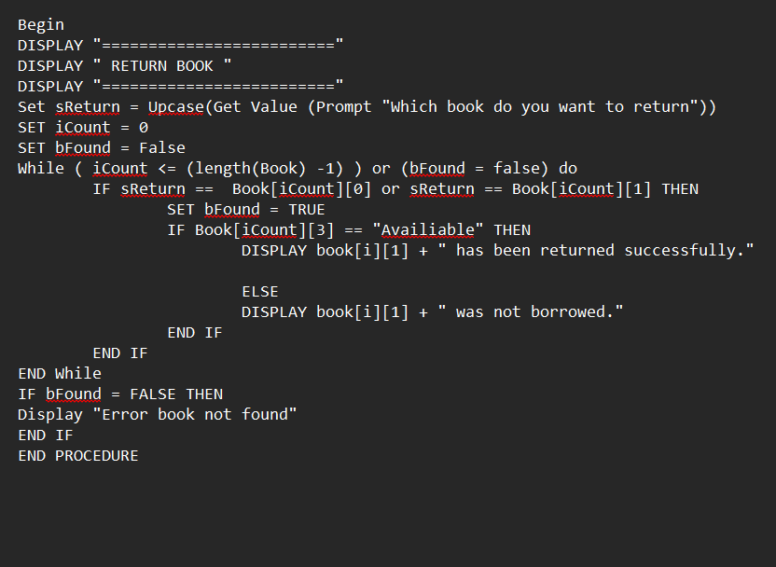

Display All Books Procedure

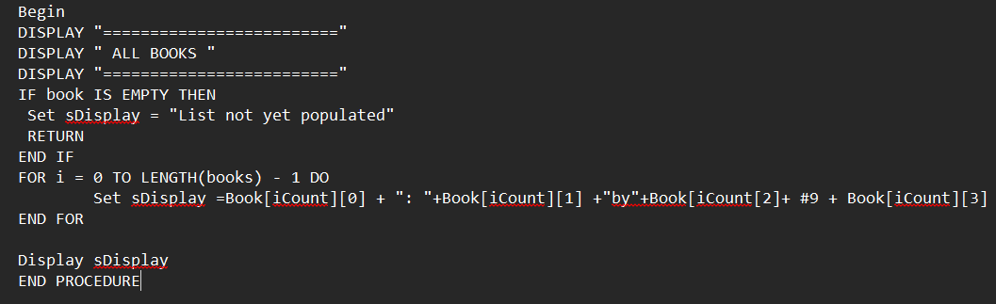

Section 3: Flowchart

Main Program
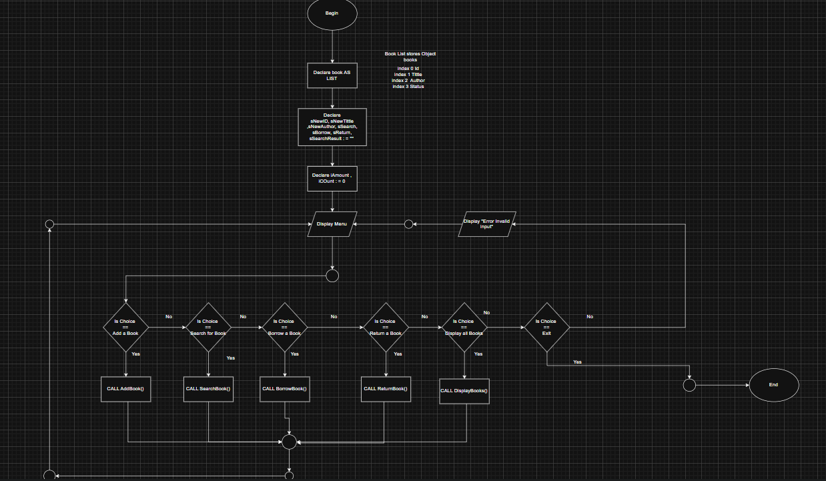

Add Book Procedure
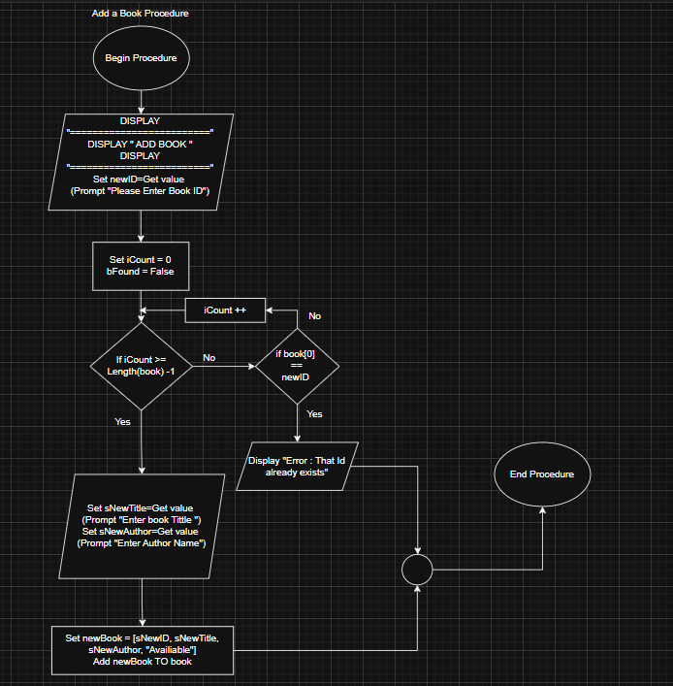

Search Procedure
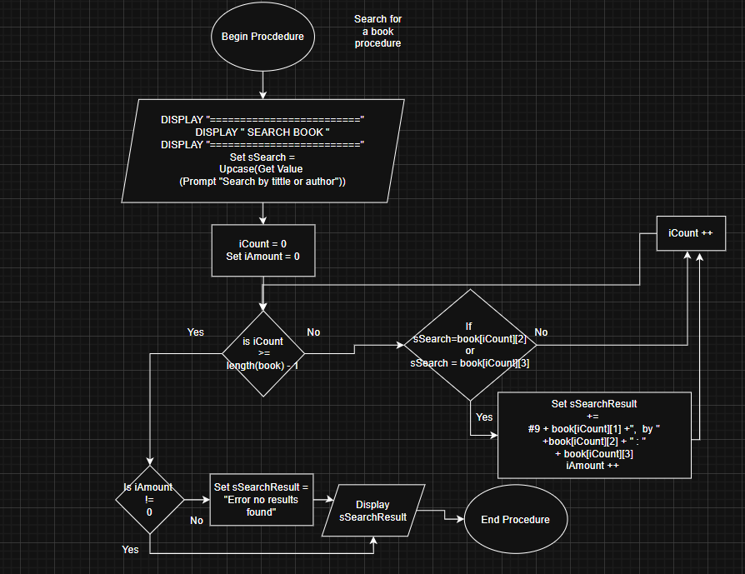

Borrow Book Procedure
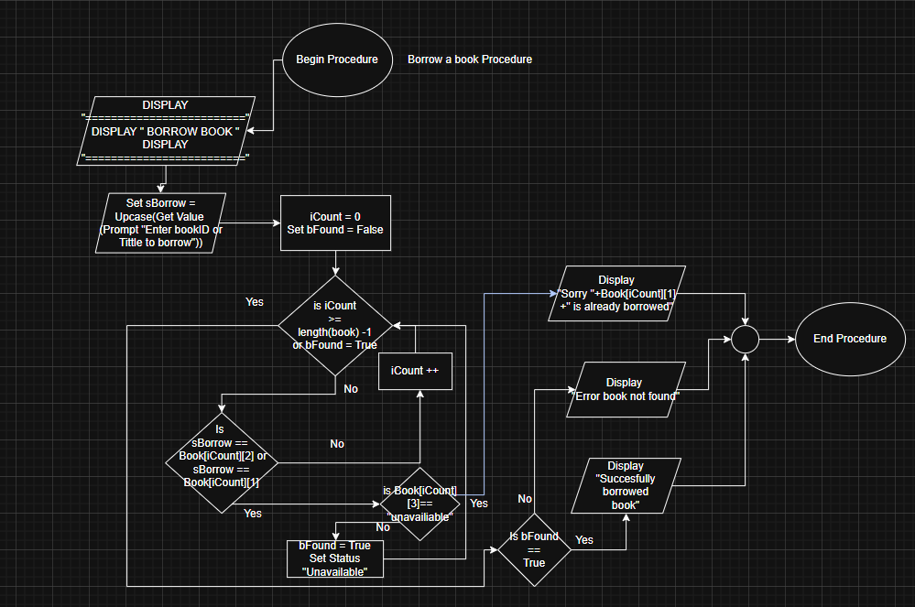

Return Book Procedure
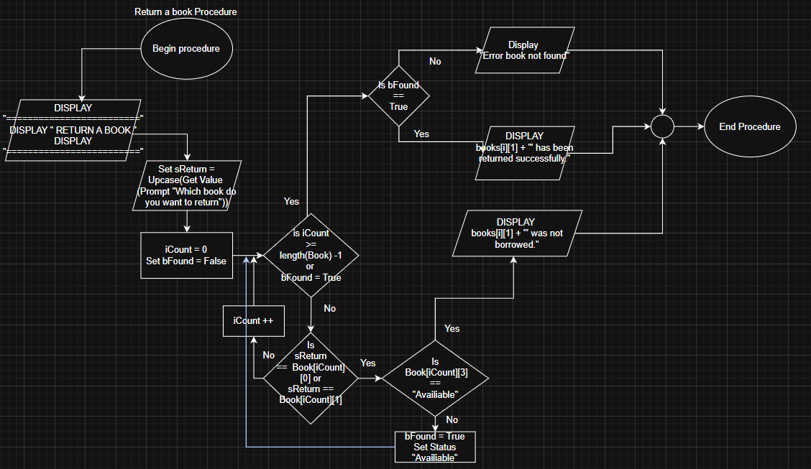

Display All Books Procedure
